Biological Indicators of Water Quality

Examining the quality of a stream or waterway can be done in many ways and with different levels of technicality. However, you don’t necessarily need high end, precision sensors, or a warehouse full of expensive equipment to know how healthy a stream in your own backyard might be. A glimpse into the biodiversity of the critters that inhabit a fresh water ecosystem can reveal abundant information about the quality of the water and the overall status of the stream.

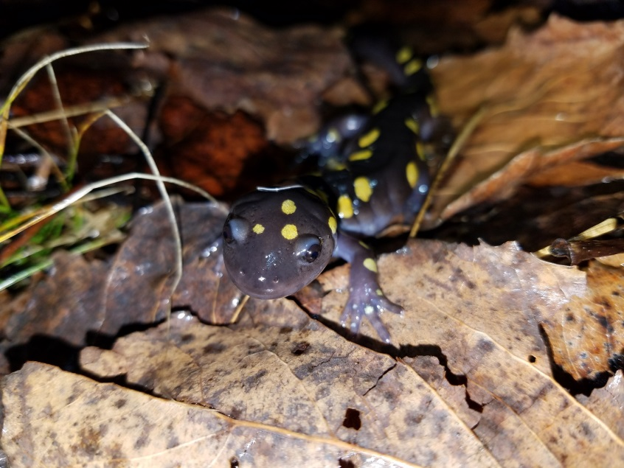
Streams in Chester County and across the globe are teeming with life. Some of that life is seen clear as day, while some hides under rocks or might even be too small to see with the naked eye. Groups of organisms that we can see and use as indicators of water quality include amphibians, macroinvertebrates, and fishes. While not true for every ecosystem, generally if you find a stream to be inhabited by many different types of species, chances are it's in fairly good health. Certain groups of animals can tell you more than others based on their living requirements and tolerances. For example, salamanders and other amphibians are unique in that they have the novel ability to breathe through their skin. This is known a cutaneous respiration. While cutaneous respiration allows them to thrive in specialized environments, it also makes them very susceptible to absorbing toxins through their skin. It would not be uncommon to find an absence of salamanders or even deceased ones in heavily polluted streams or immediately following a toxic spill event. On another note, certain species of mayflies have specific tolerances for dissolved oxygen. They can only be found in pristine streams were persistently high levels of dissolved oxygen readily flows over their featherlike gills. Individual indicators such as these provide a glimpse into the overall quality of stream.

When water quality professionals examine biological indicators, often the community as a whole is assessed. Different species are assigned certain categories or weights based on their tolerances, or special living parameters. Many metrics are measured to determine a score that correlates with a certain degree of water quality. But you don't need fancy metrics or calculations to learn about your stream’s health. Anyone with a few good identification books and an interest to explore can research the biodiversity in a nearby stream. So next time you are out and about on a hike, or walking your dog by a stream, take a second and flip over a rock or peer into a clear shallow pool. You may be surprised by what you discover.

Content provided by Tom Oranzi at Chester County Conservation District. To contact CCCD, call 610-925-4920 ext 100.

