Spotted Lanternfly

Spotted lanternflies are an invasive species threatening several industries in Chester County, including agriculture and horticulture. Penn State Extension has an abundance of information about what you can do to stop the spread of Spotted Lanternfly on their website. Go to https://extension.psu.edu/spotted-lanternfly for more information.
Spotted Lanternflies lay their eggs on the bark of trees and other smooth surfaces in the fall. Around the beginning of May, the first instar nymphs emerge from the egg masses and begin drawing nutrients from nearby plants. Each egg mass contains 20 to 50 individual eggs, so scraping one egg mass is much easier than chasing down 20 to 50 little nymphs.
Before May first, we should be sure to check our trees, firewood, lawn furniture, and other outdoor items for egg masses. We recommend that if you see them, scrape them off and put the scraped mass into a plastic bag with rubbing alcohol or hand sanitizer. If rubbing alcohol and hand sanitizer are unavailable, use a scraper card or putty knife to squish the egg masses. This method is not officially approved by any agency, but by obliterating the egg mass and the eggs within, you will be able to tell that they have no chance of survival.
The image below, from Penn State, shows the life cycle of the spotted lanternfly life cycle. 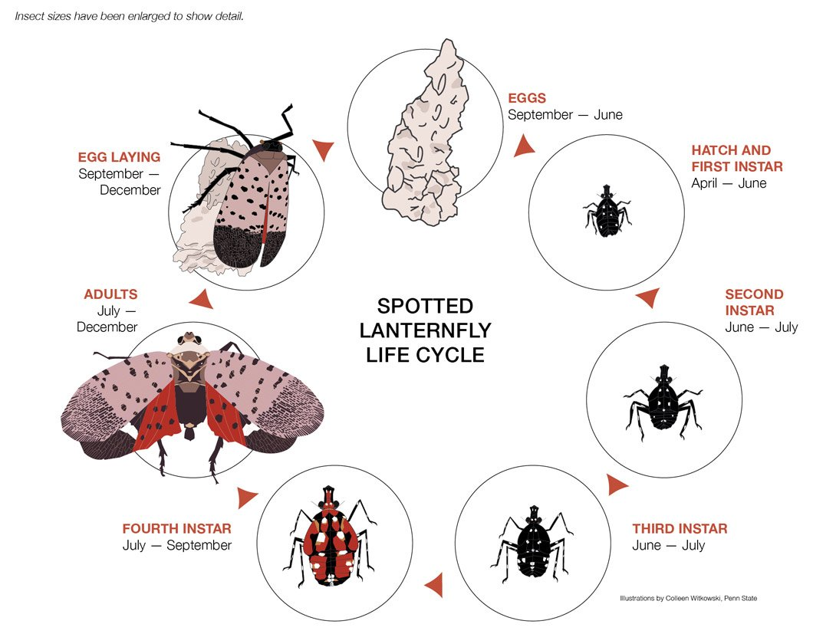

Content provided by Chester County Conservation District

