Invasive Species: Why You Should Care and How to Help

It is a common misconception that all non-native organisms are considered invasive species. In fact, some non-native species have valuable agricultural and medicinal uses. They are only considered invasive when they cause ecological or economic harm to their environment. The reason that this can become such a big issue is because humans are moving plant species to different regions at a much faster rate than the plants would spread through natural expansion. Most invasive species outcompete native organisms for limited resources and are capable of altering entire habitats. Not only do invasive plants degrade the quality of water and soil, but the further they spread, the more expensive it is to control them. Invasive plants have the ability to displace and kill off native species in pastures and cropland. Invasive pests can also cause major damage to a crop yield, resulting in economic loss.
Lists of invasive plant species in Chester County can be found through resources like the Brandywine Conservancy, municipality ordinances, or PA DCNR. A few commonly-seen invasive species present in Chester County include garlic mustard (shown in the photo), tree-of-heaven (correlated with the spotted lanternfly), Norway maple, Canada thistle, and mile-a-minute weed.
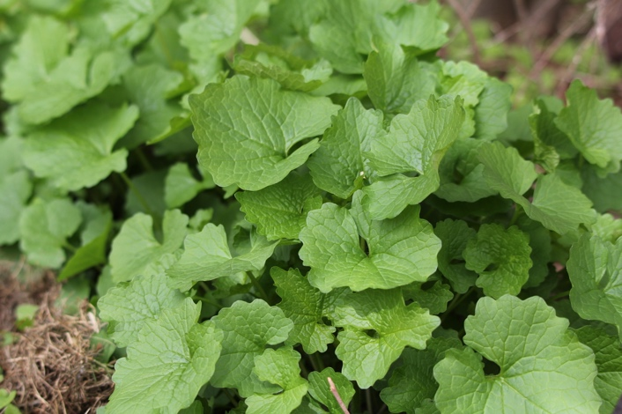
There are several ways homeowners can take action to help control invasive species in Chester County. The easiest thing to do is to take precautions such as cleaning your boots before hiking in a new area. This prevents accidental transporting of non-native organisms into a different habitat. It is also important to eliminate the introduction of non-native species like exotic houseplants or aquarium pets into the outside environment. Buying native species, especially for landscaping purposes, is an effective way to reduce the spread of invasive species. It is important to be educated on native alternatives and have a conversation with your landscaper about the types of species you want on your property.
Garlic Mustard Rosette – These invasive species release chemicals inhibiting the growth of nearby plant species
Lastly, early detection and rapid response is key to limiting Chester County’s invasive species and reducing the cost of controls. It is crucial to first familiarize yourself with plant species, what to look for, and how to dispose of invasive species properly if you choose to remove plants from your property on your own. A great way to have an impact is to volunteer with organizations and conservancies that hold invasive plant management projects. There are volunteer days dedicated to manually removing invasive plants, and even pests like the spotted lanternfly, in local parks and wildlife areas. You can report sightings to the Chester County Penn State Extension Office and find more information through DCNR and PA Department of Agriculture.

Content provided by Chester County Conservation District

