Want to Learn more about how to improve water quality in Chester County?

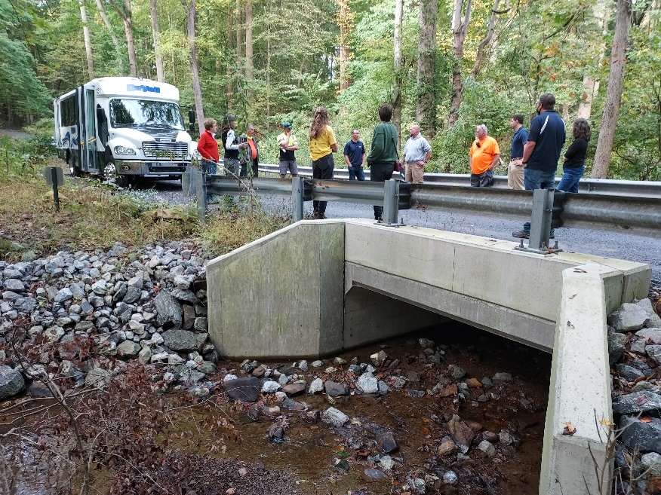

Check out the CWMP calendar for an UP-TO-DATE list of activities and programs.

These activities include:
tree planting events, best management practice workshops, stormwater training and more!
To learn more visit https://cwmp.org/cwmp-calendar/. For more information about stormwater management in (enter municipality) visit (website link).

