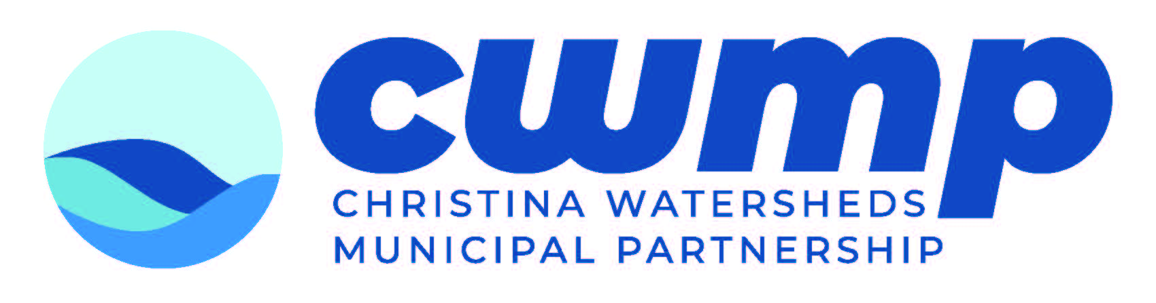
Do you Grow Crops or Keep
Livestock on your Property?
Learn how you can ensure clean water through
Agricultural Best Management Practices such as:

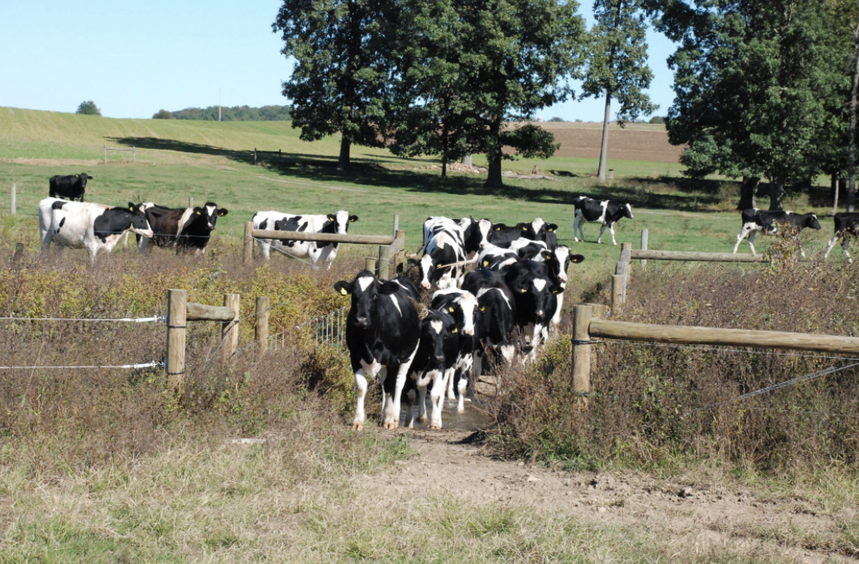
Conservation Plans
A document created by the farmer and a conservation planner to identify resource concerns and create a plan of action.
Nutrient Management
These plans document nutrient sources and aim to keep them separate from clean waterways in the surrounding area.
Agricultural Funding and Technical Support
Funding programs are available to help agricultural landowners and operators implement practices that improve water quality.

For more information on these practices, visit www.cwmp.org/farmer_resources For more information about stormwater and agricultural requirements in (enter municipality) visit (website link).
.

