Simple ways

homeowners can protect

our watersheds
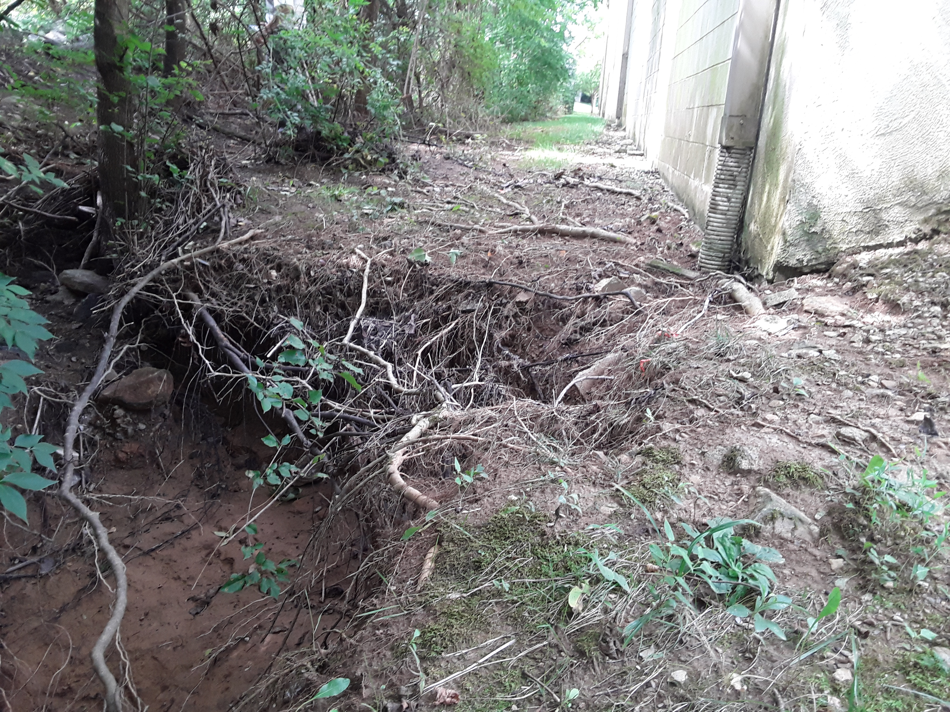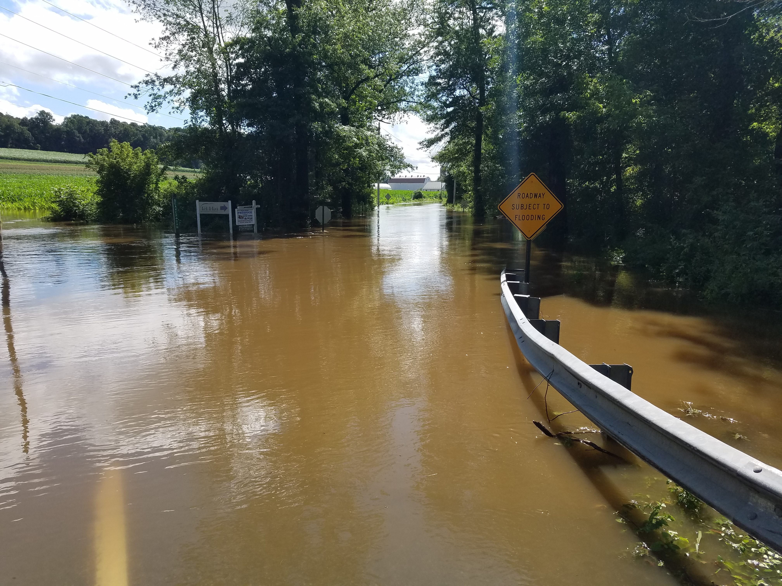  The dangerous effects of flooding can be reduced by doing simple tasks like these! |  | Plant a Rain Garden  Rain gardens are strategically designed landscapes that capture and absorb rainwater, allowing it to infiltrate into the ground rather than flowing untreated into storm drains or causing flooding.  Reduce Use of Pesticides, Fertilizers & Deicing Chemicals  Limiting household use of harmful chemicals can prevent nutrient overgrowth and plant/animal death in our waterways.  Plant Trees/Riparian Buffers  Planting trees prevents flooding, lowers water temperatures, improves air quality, sequesters carbon and adds value to the neighborhood.  For more information on these techniques and more green stormwater practices check out www.cwmp.org/homeowner_resources. For more information about stormwater management in (enter municipality) visit (website link).

