Thinking about an addition or expanding pavement on your property?

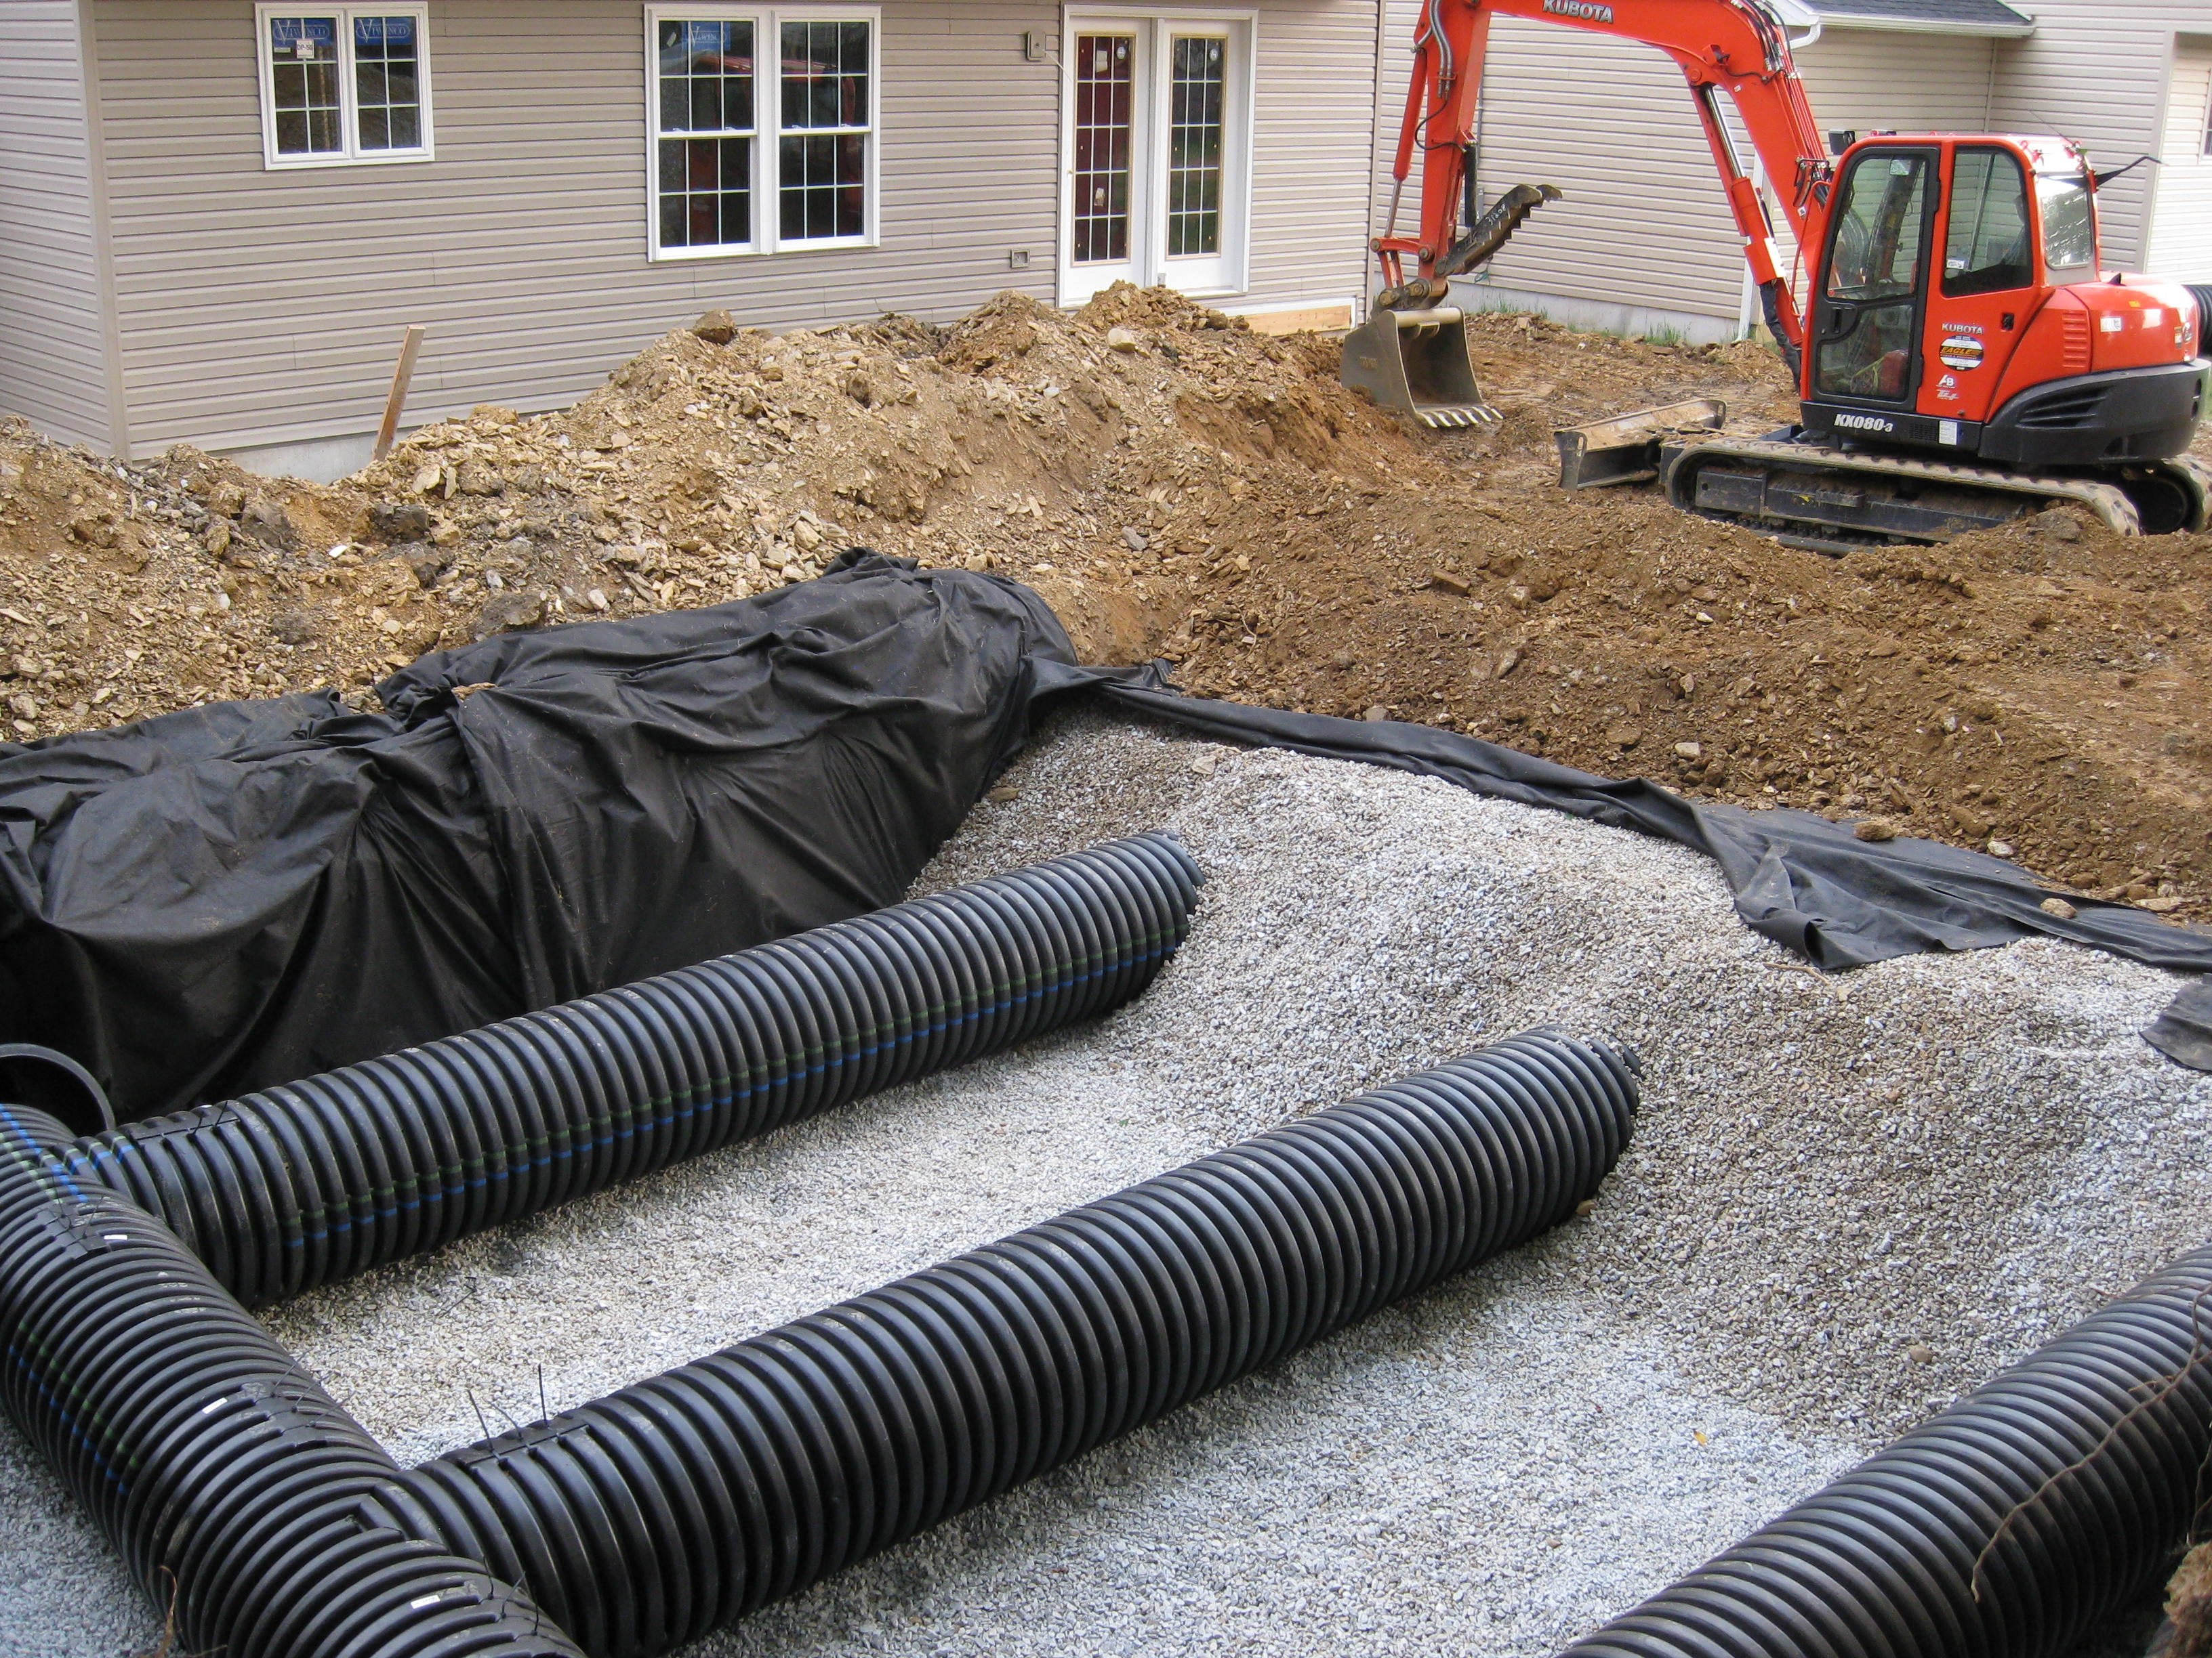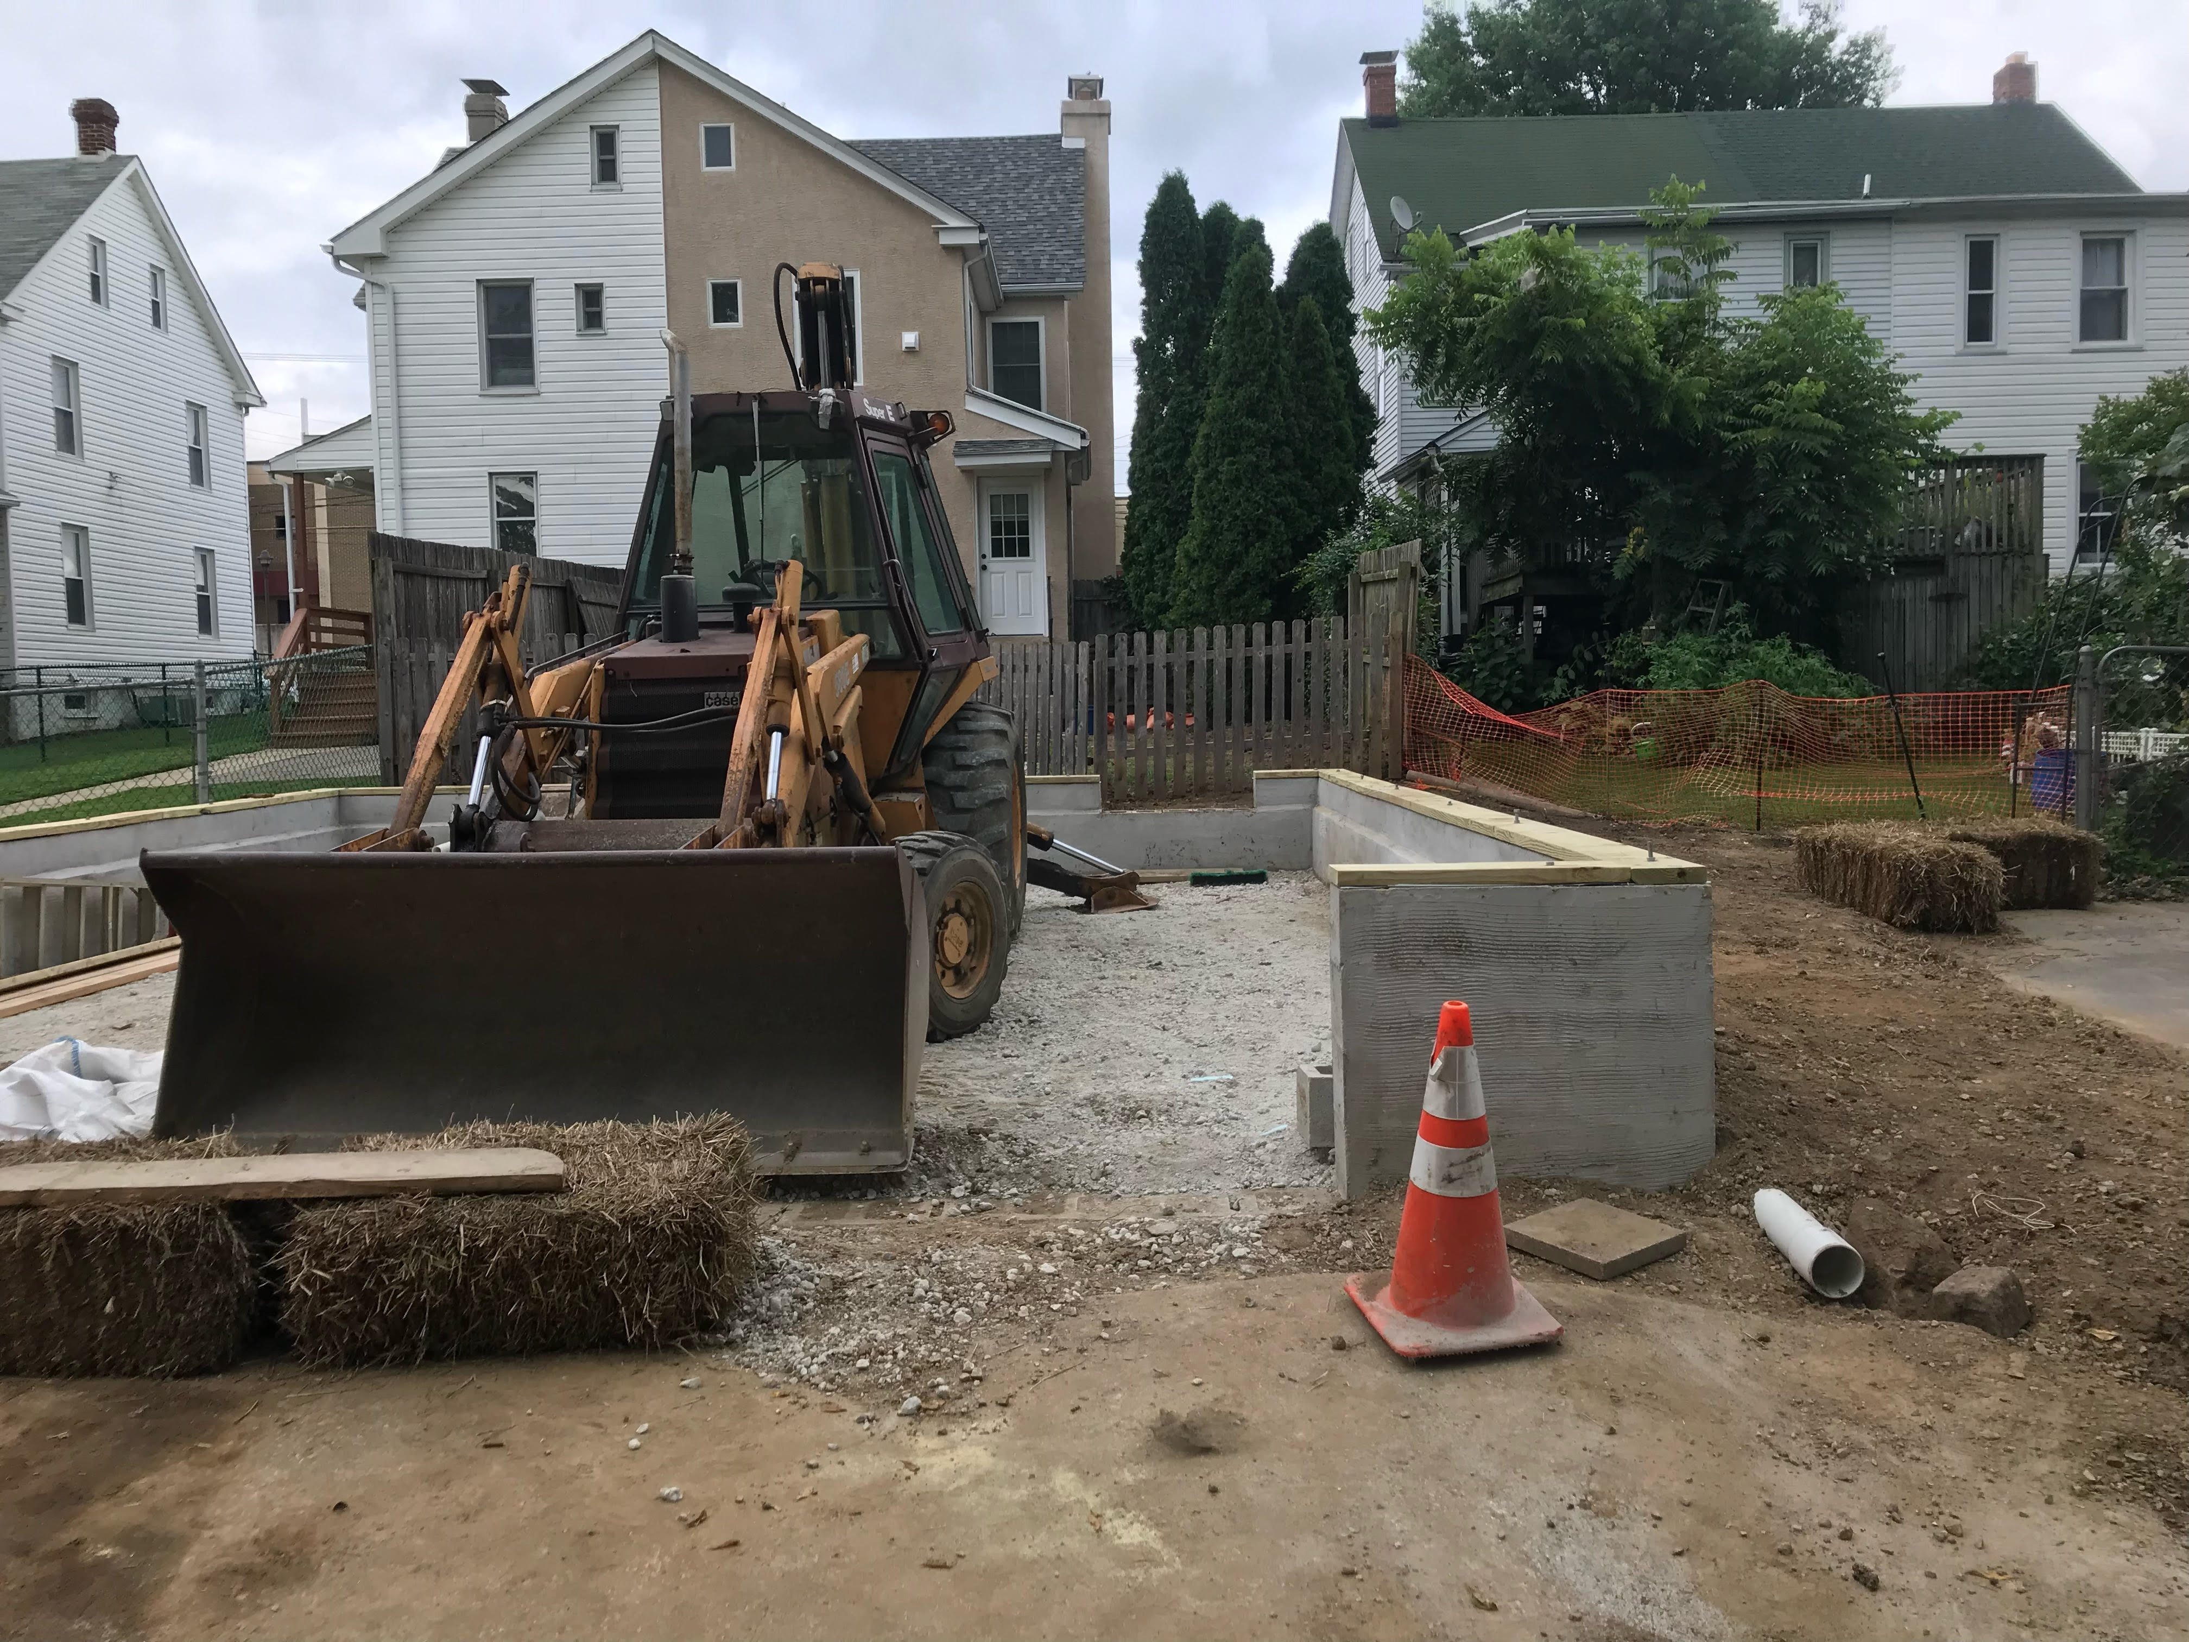
Stormwater control should be considered at 4 separate stages:

- Planning for runoff
- Controlling runoff during construction
- Controlling runoff in completed project
- Long-term maintenance of runoff control
To learn more about building project resources visit https://cwmp.org/developer_resources/ . For more information about regulations and best practices for land development in (enter municipality) visit (website link).

